Washtenaw County

Juvenile Detention Center

Resident Orientation Manual

“The Key To Your Success At The Detention Center!”

WHAT IS THIS HANDBOOK ALL ABOUT?

There are some things that you should know, before you enter the program that will make your stay here at the detention center more productive. These things will also help you in getting along with the staff and other residents. When you finish reading this guide a staff member will review the expectations with you and then you will be given an orientation test.

Knowing the correct answers will help you pass this test and do well in the program.

It is important that you understand everything in this handbook as it contains all the answers to the program entrance test.

You will progress in the level system once you show that you understand the behavior program expectations. There will be a test to advance from level 1 to level 2, and another test to advance from level 2 to level 3.

You must earn the expected number of points and pass the appropriate level test to advance levels.

If you have any questions, or find something in this orientation handbook that you do not understand, please ask one of the staff to explain it to you!

IMPORTANT INFORMATION ABOUT YOUR RIGHTS

- Treatment While in Custody:

- Upon being taken into custody everyone shall have the right to remain silent.
- No unlawful means of any kind shall be used to obtain a statement, admission of confession from any person.
- Persons in custody shall be treated humanely and provided with proper food, shelter and, if necessary medical treatment.

- You have the right to communicate with your attorney and family, particularly upon
admission or transfer to another facility, you must be provided a reasonable number of telephone calls to accomplish this communication.

- You have the right to consult with an attorney.

IMPORTANT INFORMATION ABOUT THIS FACILITY

Where am I? You are currently staying at the:

Washtenaw County Juvenile Detention Center
4125 Washtenaw Avenue
Ann Arbor, MI 48108

The telephone number here is (734) 973-4343

What is this place?
The juvenile detention center is a place where juveniles who have been ordered by the court or who have been charged with criminal offenses are held.

The basic purpose of the detention center is to provide you with safe and secure
custody and help you to make positive changes in your thinking and behavior.

When will my parents be notified of my detention?
Detention center staff will inform your parents/legal guardian, as soon as possible, of your detention. As such, it is very important that you give us accurate information about your parent’s current telephone numbers for work and home. We will also inform your parents of all our programs as well as your court date and time. They will also be notified to obtain an attorney. Please note that only your parents will be informed of your detention.

When will I have court?
If you have not already had court you will have a “Detention Hearing” within one working day (24-72 hours) of your detention. Generally, you will go to court the day after you come to the Detention Center at 1:30 pm on weekdays and 10 am on Saturday morning.

The purpose of the Detention Hearing is for the Court to determine if you need to remain in the detention center during your continuing court process.

What professional visitors can I have during my detention?
Approved case related professionals are allowed to visit you during you detention stay. This could include your (1) Lawyer (2) Probation Officer (3) Caseworkers (4) Clergy (Priest, Rabbi, Minister, etc.) (5) Counselor(s), Therapist (6) School Staff.
Whenever you need to speak with a professional involved in your case just ask a staff and we will coordinate the process.

Where do I sleep?

To help assure your safety and security and that of other residents you will have you own sleeping room.

Your sleeping room will have all the necessary equipment for you to address your personal needs. Your sleeping room also has an intercom system with a “call button” so that you can talk directly to staff should you have an emergency. Do not use the call button unless you or someone in your Unit is having a genuine emergency. Staff should come by and do visual checks every 15 minutes and can handle all non-emergency requests then.

How is my safety assured during my detention?
The detention center uses equipment to help us supervise people and assure you are safe and secure while here. We use audio and video devices to listen and watch activities. However there are no hidden cameras in your sleeping room, washrooms, shower rooms, conference rooms, or medical examining rooms.

How do I have a private or confidential meeting?
Special meeting rooms are provided so you can have confidential conversations with case related professionals. Conference rooms and the medical consult rooms are reserved for private meetings with your attorney, religious advisor, medical staff, and other professionals connected with your case.

What if I have medical needs or counseling needs?
The detention center has a licensed nurse available to respond to all your medical needs. We also have a therapist available to help you with any concerns or other problems that may arise during your detention stay.
Within 72 hours of your arrival our medical staff will have you complete a physical examination, tuberculin test and medical history interview.

Please be certain to report to us immediately if you are sick, injured, require medical attention or are currently taking prescribed medications. If you would like to see a mental health staff, ask a counselor or supervisor and they can arrange for a social worker or psychologist to see you.

Who are the staff?
There are Youth Counselors and educators who will work with you during your detention stay. They are trained to assist you to learn rational thinking and behavior that will assist you in making positive changes. They will also help you have a safe and secure detention stay.

When do I eat?
You will receive three (3) meals each day and a snack each afternoon and evening before bedtime. All your meals will be provided by the food service at the detention center.

What personal supplies do I get?
The detention center will provide you with clothing, bath (hygiene) items, reading materials and bedding (linens). You will shower daily and are provided with soap, shampoo, washcloths, towels and other personal hygiene supplies. If you have special hygiene needs (contacts, braces, retainers, etc.) please let a staff member know right away so we can make necessary arrangements for you to have these items.

When can I visit my family and make telephone calls?
During your detention stay you will be able to telephone and visit your parents and other court approved visitors.

Visitation occurs three times per week and is open to you regardless of your level.

Phone calls must be purchased at the store.

VISITATION SCHEDULE

Up to ten youth may have visitation during each session on a first come-first served basis. If the first session is full, visitors are welcome to wait for the second session.

No more visitors will be admitted after the end of the registration period until the next visitation session.

Wednesday Schedule

First Session:
Registration Period: 4:10 p.m. to 4:20 p.m.
Visitation Period: 4:20 p.m. to 4:50 p.m.

Second Session:
Registration Period: 4:50 p.m. to 5:00 p.m.
Visitation Period: 5:00 p.m. to 5:30 p.m.

Saturday and Sunday Schedule
First Session:
Registration Period: 1:00 p.m. to 1:15 p.m.
Visitation Period: 1:15 p.m. to 1:45 p.m.

Second Session:
Registration Period: 1:45 p.m. to 2 p.m.
Visitation Period: 2:00 p.m. to 2:30 p.m.

Will I get mail?
You will receive your mail on the day it arrives. However, there is no delivery on weekends and holidays. You will be able to write and receive letters from any approved visitors through the U.S. Postal Service.

We will provide you with stationary, stamps, and envelopes so you can send mail to people on the approved visitors list. You must use your name and our return address when sending mail out. You are required to seal outgoing mail in the presence of staff. Staff will open all incoming mail, in our presence, so that the contents can be inspected to find any inappropriate items.

Do I get any exercise?
You will be able to go to the gym and the outdoor play area when you are participating in the program.

Do I get any books or reading materials?
The detention center has a library and you will have regular access to reading materials. You are allowed to use up to two books and one Bible or religious text at a time.

What will I be doing while I’m at the detention center?
You will be participating in various educational programs, discussion groups, gym and free time activities, art, custodial responsibilities and community service opportunities.

Will I go to school during my detention stay?
Yes, you will go to school.
  - School is conducted Monday through Friday throughout the entire year.
  - You will enter the school program once you complete the orientation process.

WHAT CAN I EXPECT FROM THE STAFF?

The primary goals of the staff are to help you:

- Assure your safety and security.
- Assume responsibility for your behavior.
- Develop problem solving and social skills so that you will not have to return here and that you might experience greater personal success and involvement with your community.

As a new resident you may wonder what the staff are like and what you can expect from them. You can expect the following from staff:

- Safety and Security – staff are here to assure that you are safe and secure

- Honesty – staff will be straightforward with you and not play games

- Help – staff will assist you in problem solving

- Goal Setting – staff will help you in choosing reachable goals and planning the most efficient way of getting there

- Consistency – staff will always provide you with consequences for both positive and negative behaviors

- Mistakes – everyone makes mistakes and staff also make mistakes because we are human beings and are not perfect

- Confidentiality – staff will not discuss your performance here, the reasons for you being here, or your family situation with anyone for whom it is not appropriate

- Listening – staff will listen to your concerns whenever the time and place are appropriate

- Responsibility – the staff will accept responsibility for their actions but they will refuse to accept responsibility for your behavior

WHAT IS EXPECTED OF ME REGARDING MY BEHAVIOR HERE?
Appropriate Behavior is any behavior:

- which moves you closer to your goals
- that helps you earn rewards
- that improves your chances of never coming back to the detention center
- that is helpful to you and others

Inappropriate Behavior is any behavior:

- which keeps you from your goals
- that interferes with earning rewards
- that interferes with your future
- that gets you into trouble
- that is harmful to others

WHAT IS THE RBT PROGRAM?

RBT stands for Rational Behavior Training. It is a program developed to help you change the way you think, and help you make more positive choices.

Participation in the RBT program is required, and it can really help you succeed here and after you leave here as well.

You will receive an RBT handbook that will guide you through the program, but if you have any questions, please ask a staff member immediately.

WHAT HAPPENS AS A RESULT OF MY BEHAVIOR HERE?

There are a number of privileges and activities that can be earned for appropriate behavior.

If your behavior does not meet expectations you will not earn points and you may also earn time outs.

You will notice that staff members are constantly evaluating how many points you are earning based on the appropriateness of your behavior while you are here. They do this by writing down on your POINT SHEET the number of points you have earned for a period of time.

Remember that points are earned by you and cannot be taken away. Each time period is a fresh start for you to earn points.

What is a point sheet?

You earn points for active involvement in the program. Your point sheet is what staff use to keep track of the points you earn for appropriate behavior.

The more appropriate your behavior is during that time, the more points you will earn.

Higher levels are earned by earning more points. The higher your level the more privileges you can earn.

Some of the privileges residents can earn include staying up later, movies, more recreation, better store items, etc.

A maximum of 5 points can be earned in each of the target skills for each time period of the day. Additionally, you can earn up to 15 points for a clean and tidy room.

You can not earn points while out of the program on a timeout. For example, if you spend 30 minutes in timeout, the most you can earn in any target skill category is 4 points.

There are five (5) target skills.

- Ignore
- Gestures
- Cooperation/Participation
- Area
- Talk

The week in detention goes from Thursday morning through the following Thursday morning. Points for levels are totaled after Wednesday midnight and start fresh on Thursday morning. This means new levels take effect Thursday morning after you complete the appropriate Level Advancement Quiz.

On the next page are examples of appropriate and inappropriate behavior for each of these target skill areas.

TARGET SKILL EXPECTATIONS

Examples of expectations
Appropriate Behavior Inappropriate Behavior
Ignore  All of us like the attention of others from time to time. Sometimes people will behave in an inappropriate manner just to get attention. If you pay attention to those who are behaving inappropriately, you may be encouraging them to behave in this way again. Obviously, we don’t want to have inappropriate behaviors encouraged by a staff or resident. Ignoring means acting as though you are not aware of that person’s behavior at all. | Ignore  Watching other Units or residents that are not in your Unit: Laughing at another resident is inappropriate behavior.
Gestures  We say things not only by talking, but also by our facial expressions, motions of our body, and even our posture. Appropriate gestures include: a smile when someone succeeds at a difficult task, a nod of the head at someone else’s appropriate behavior, or shaking someone’s hand. | Gestures  Some gestures that are not appropriate: shaking your fist in someone’s face, laughing when someone else gets into trouble or get hurts, touching someone aggressively or sexually.
Cooperation/Participation  We all depend on others for our health and well being. There are many people in this building, so cooperation is very important so we can all reach our goals. Cooperation means working together. Things can get done more efficiently and all of us will be able to get along better with one another. It is also important to participate in all program activities. | Cooperation/Participation  Examples of not cooperating or participating are not following directions, not raising your hand in activities, not doing your work in school.
Area  Staff are expected to know where you are at all times; therefore, before leaving any areas you are expected to ask permission of staff. You should always bring what you need to what you are doing. You are expected to clean up an area before leaving it, this includes your room. | Area  If you don’t have staff’s permission to leave an area, when you are not where you should be or when you are late arriving you disrupt programs. If you don’t bring the appropriate materials, it will take time away from doing what you and the others are doing. Leaving your room messy is an example of poor area.
Talk  Appropriate talk is highly encouraged! Thinking is really talking to yourself silently, and when done rationally, can help reach better decisions. Talking and thinking can be both useful in avoiding problems and solving problems. Appropriate talk is considerate of others, encourages others to act and talk appropriately. Some subjects for appropriate conversations are music, sports, cars, school, future plans, friendship, jobs, personal goals and hobbies. | Talk  Inappropriate talking is talk, which keeps you from getting to your goals, earning rewards or in any way is likely to cause you problems. Some inappropriate subjects for conversation are drugs, why you are here, drinking, gangs, any law breaking activity, complaining about consequences and staff, satanic activities, weapons, fighting, swearing or using foul language.

What is a GOAL contract?

In addition to earning points for appropriate behavior you will also have a personal contract to follow if you want to participate in the Unit Plus Party.

Contracts are written agreements you make each week to work on changing or improving your behavior.

At the bottom of the point sheet is an area marked “contract”. It will show what your contract is for that week. Staff members also call this your weekly goal.

Staff will write in this area the types of behavior and improvements you are making and, if you are working to accomplish your goal, you will be awarded a contract PLUS (+).

You can earn up to two contract pluses per day, which is a possible total of 14 per week.

Earning 11 plusses in a week will grant you access to the Unit Plus Party on Thursday evening. The party will include special food and desert, as well as videogames, special activities, prizes, and a later bedtime reserved only for the youth who achieve their goals for the week.

Goals for goal contracts are set at the Thursday afternoon group meeting, with input from entire group and all the group leaders for that unit. The first Plus (+) opportunity for a new goal is the Thursday evening group meeting. The last Plus (+) opportunity for an existing goal contract is the Thursday afternoon group meeting.

What are coupons?

Coupons are used to reward you for new appropriate behaviors and for continued acts of positive behavior going above and beyond expectations.

Coupons may be spent on various privileges or items at the detention store every evening.

Some of the items you may purchase include treats, upgraded personal hygiene items, additional privileges and phone calls, and various other rewards for good behavior.

What will my point sheet look like?

Your point sheet shows the five areas of target skill expectations and the 6 time periods each day in which you earn your points. It also shows your contract for the week and the contract plus points you earn. Here is a sample point sheet for one day of the week. 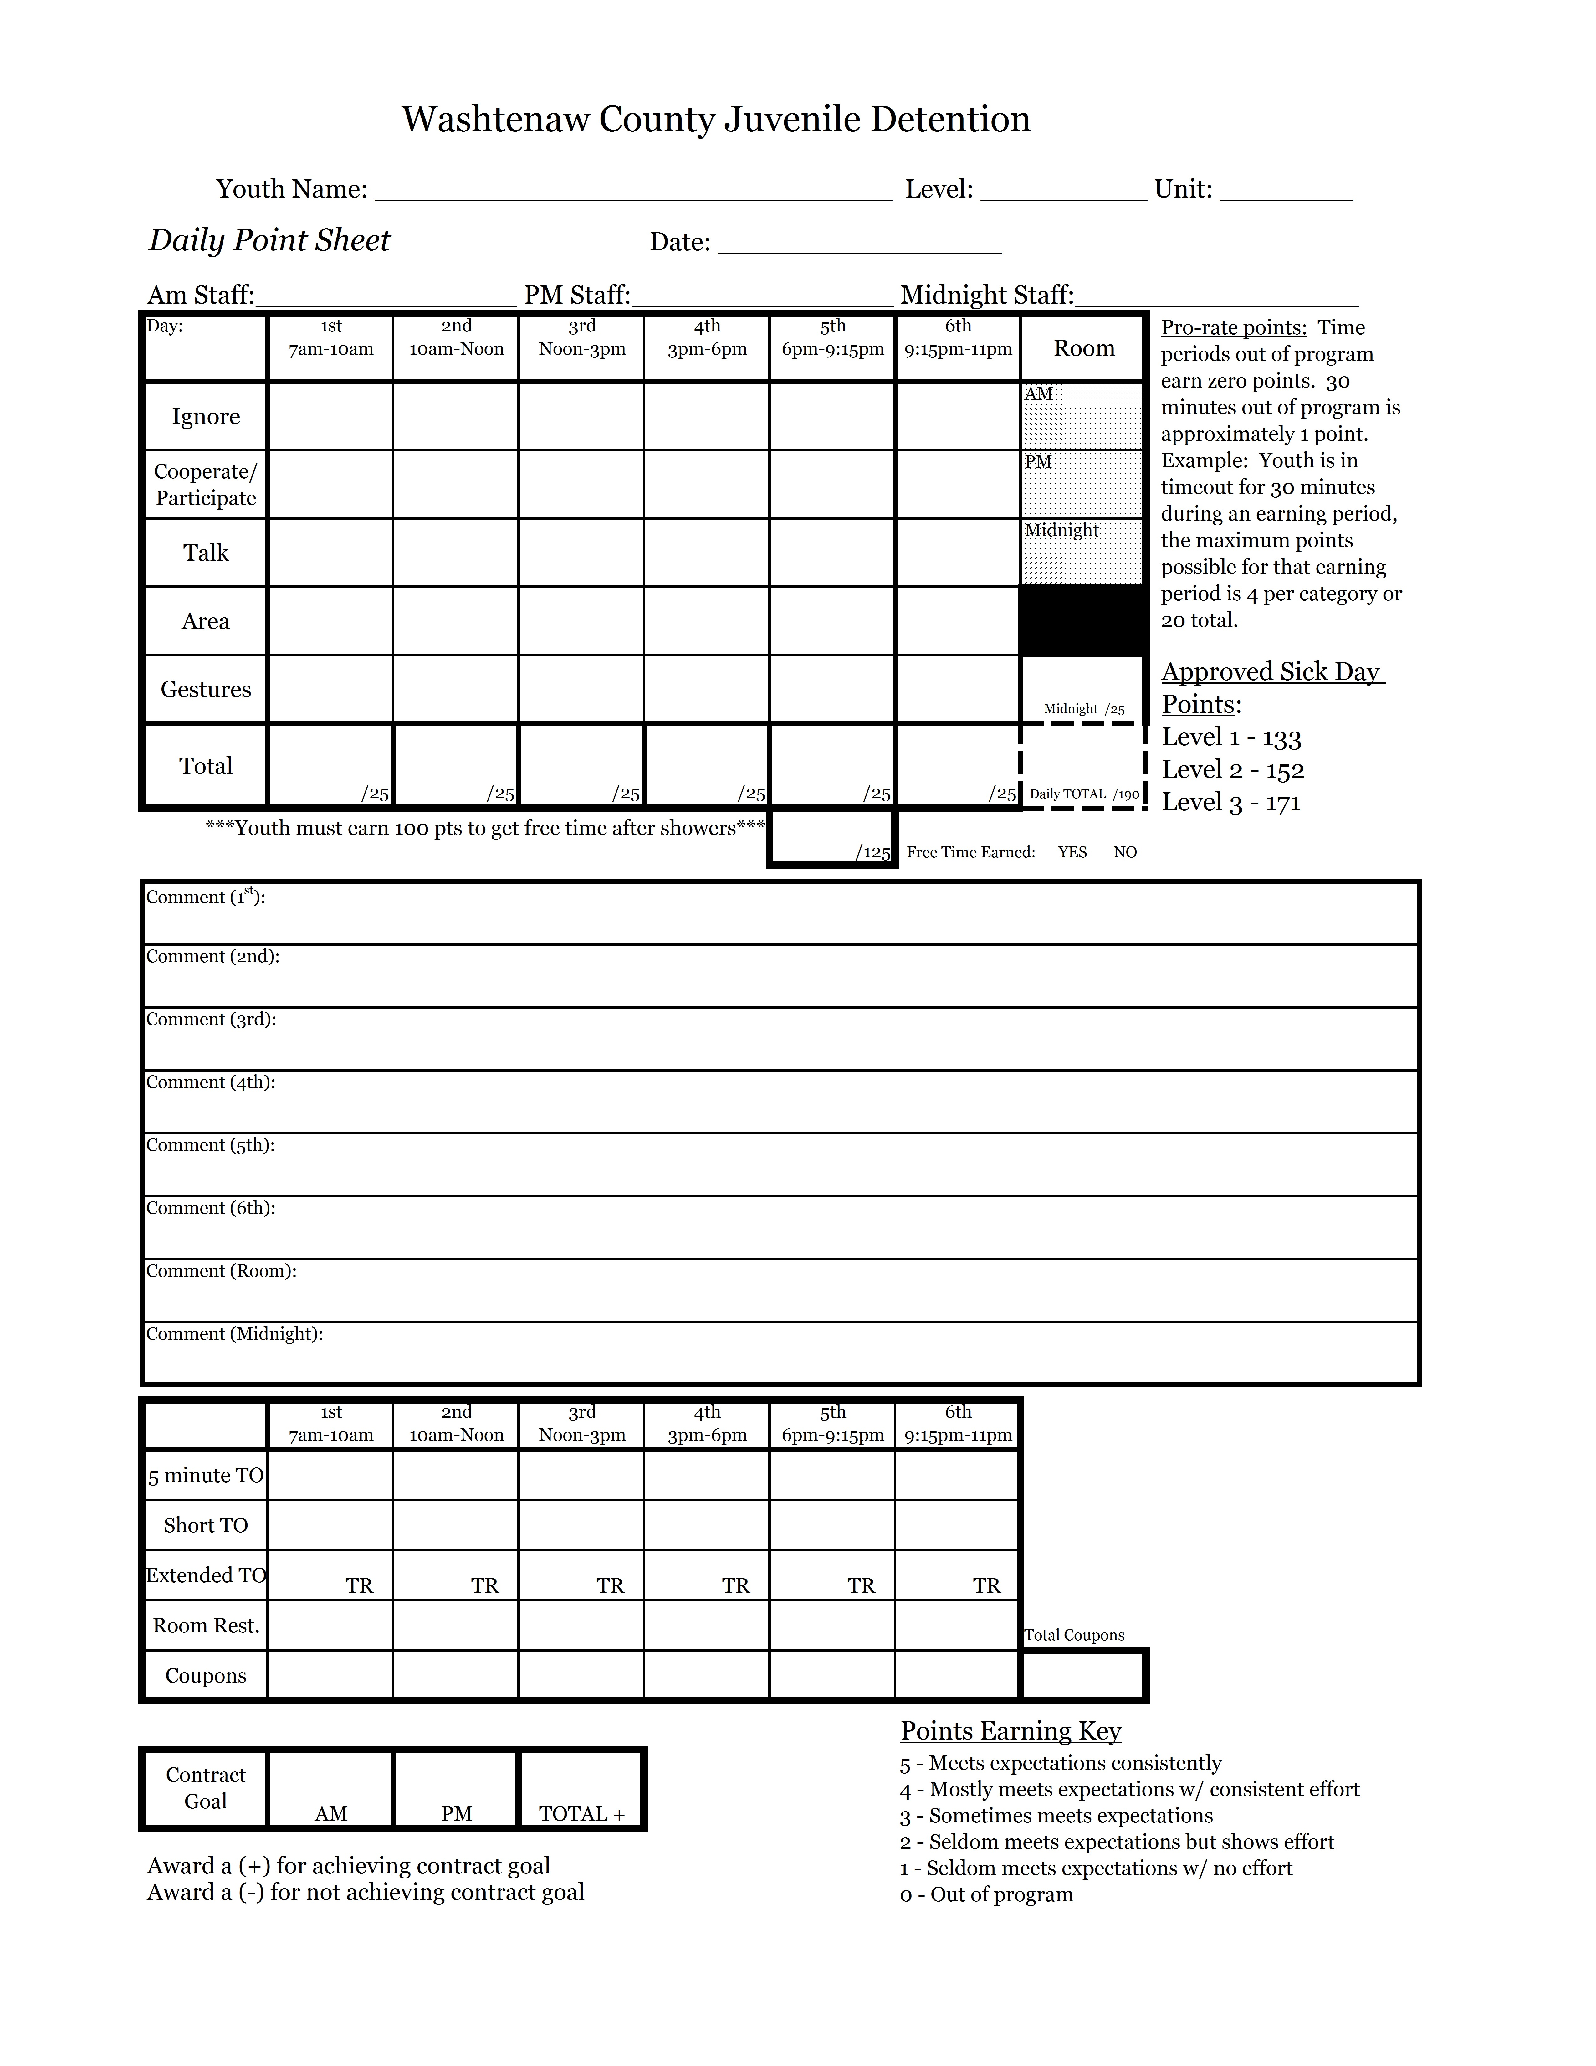

How do I earn more privileges?

There is an Orientation Phase and then three (3) levels in the program. All residents will begin the program in the Orientation Phase. Your privileges are limited during the Orientation Phase. Once you pass through the Orientation Phase, you will advance in the level system by earning the required number of points. The chart below describes what you need to earn to advance in the level system.

Upon your admission to the detention center you receive a copy of the Resident Orientation Manual. That is what you are reading right now. Once you complete your review of the orientation handbook you will take a quiz to make sure you understand the expectations. You must pass the Orientation Quiz to begin Level 1.

As you move up the level system you will earn more and more privileges. There are many posters throughout the facility that explain these privileges. A staff member can also explain the privileges to you.

Level 1
To advance from Level 1 to Level 2 you may:

- Average 152 points (80%) per day, which is at least 1064 points for the full earning period
- Pass the RBT Level 2 Advancement Quiz

If you don’t earn at least 100 points through showers, you will not earn free time for that day. There are a total of 190 points possible per day.

Level 2
To maintain Level 2 you need to:

- Average 152 points (80%) a day, which is 1064 points for the full earning period
To advance from Level 2 to Level 3 you need to:

- Average 171 points (90%) a day, which is at least 1197 points for the full earning period
- Pass the RBT Level 3 Advancement Quiz

If you don’t earn at least 100 points through showers, you will not earn free time for that day. There are a total of 190 points possible per day.

Level 3
To maintain Level 3 you need to:

- Average 171 points (90%) a day, which is at least 1197 points for the full earning period

If you don’t earn at least 100 points through showers, you will not earn free time for that day. There are a total of 190 points possible per day.

Level Advancement Tests
Level advancement tests are taken on Thursday morning after hygiene. You must answer all the questions correctly to pass your level advancement test. If you don’t know all of the information and miss a question, you will be given the opportunity to take the test again before Thursday afternoon group. Staff will give you your original level advancement test so that you can see what information you need to learn. Take advantage of the second chance and spend some time studying so you can pass your test before Thursday afternoon. We want you to know all the information so you can get to the next level. You can do it!

What is expected while you are in detention?

LOCKER
Lockers should remain closed except to put in or take out appropriate items. Lockers should only contain individual hygiene products and store items, and they must be arranged neatly.
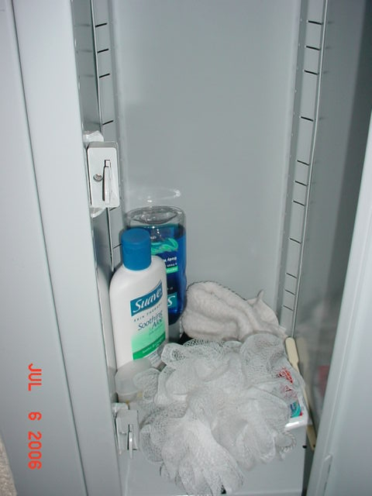

SANDALS
Sandals are to be worn at all times except during recreation and when in your room. While in your room, your sandals are to be placed outside your door, lined up with the wall.
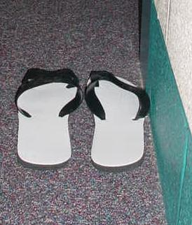

SHOES
Shoes are to be worn only during recreation. While wearing shoes, both straps are to be fastened appropriately. While in your room, your shoes are to be placed outside your door, lined up with the wall.
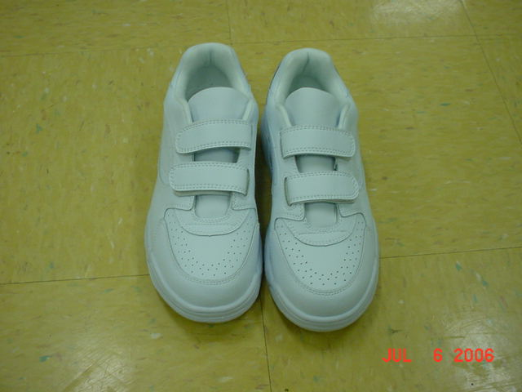

FURNITURE
Furniture may be moved to accommodate activities, however, when leaving the unit, the furniture must be arranged neatly.
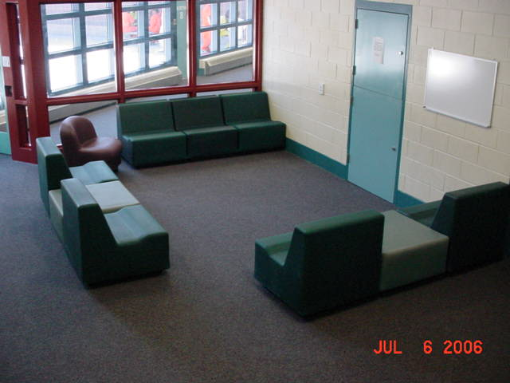

HYGIENE
Hygiene consists of detention-issued items, such as a toothbrush, toothpaste, comb, brush, pick, deodorant, and feminine products. Hygiene also includes nurse-approved medications and supplies, eye care (contact lens/case, glasses/case, solution), and personal items purchased from the detention store.
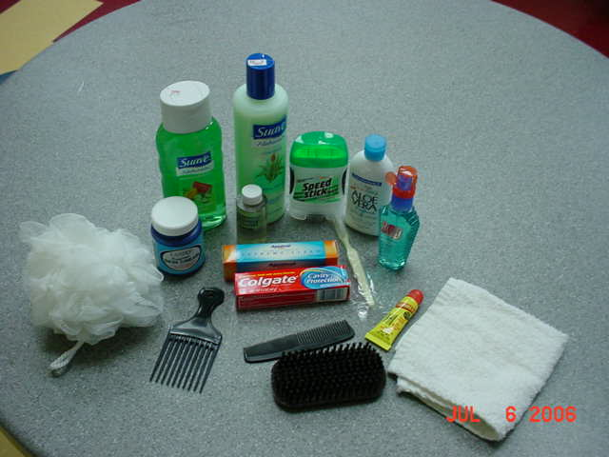

YOUTH ROOM
Rooms must be neat and orderly. The room consists of the bedding, floor, desk, sink, and toilet areas. Sheets and blankets are to be folded in halves, piled from largest to smallest, and placed at the corner of the mattress. The floor is to be clear, with nothing placed on it. The desk and shelf (if applicable) is to only have court or school papers and books on it. They are to be stacked from largest to smallest and placed on the corner of the desk or shelf. If the room does not have a desk, stack papers and books from largest to smallest and place them on the floor near the bed corner. The sink and toilet must be clean at all times. Disinfecting of surfaces should be done routinely to remove any stains.
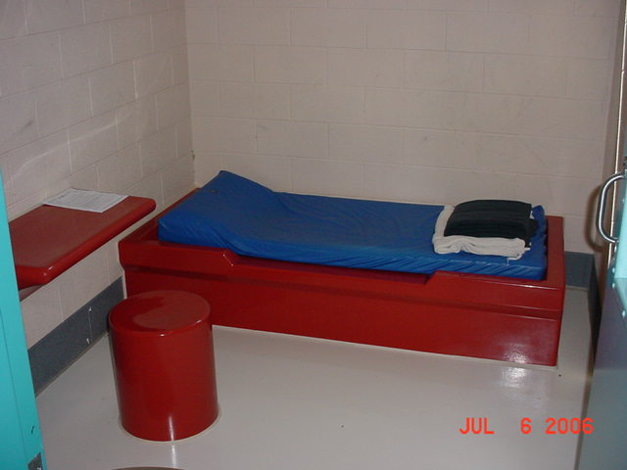
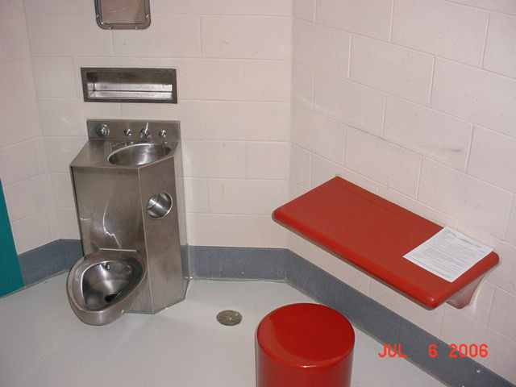

ROOM ITEMS
Items allowed in your room include two books from the library, one spiritual/religious book, court paperwork, and appropriate level privilege items.

SHOWERS
Magnet completely covering door window.
Only two youth of the same gender out of their rooms at a time.
You are only allowed to use your own hygiene items.
You are expected to complete your shower in a timely manner, without horseplay.
Dirty clothes, towels, and washcloths are to be placed in the laundry basket.
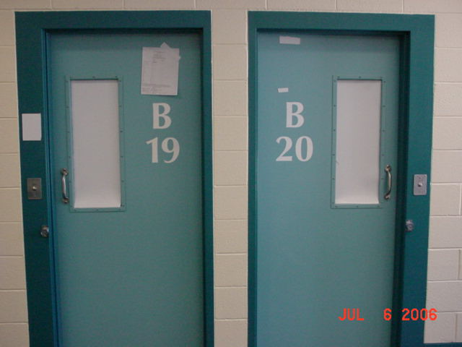

FLOOR
No food, papers, or other objects should be left on the unit floor, with the exception of shoes and sandals.

CLOSETS
Storage, unit, and television closets should be kept neat and tidy. Leave these areas neat and tidy after using them.
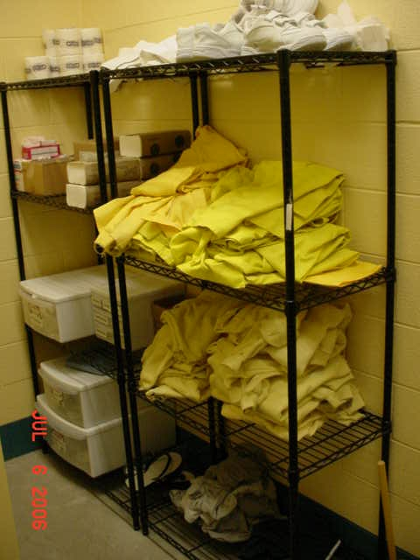

LIBRARY
The library is available for you to borrow books to read while in detention. The books are Washtenaw County property and must be returned when you are finished reading them. The library should remain neat and orderly at all times.
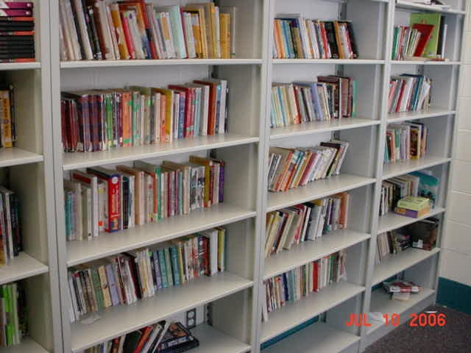

LINE
You are expected to be in a single-file line with your hands behind your back. Girls are to be in the front or the back of the line at all times. Talking and leaning on doors or walls is not allowed while in line. Under no circumstances should you push a button or open a door while in line.
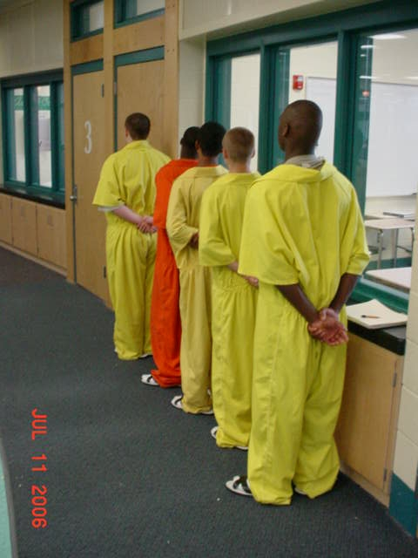

UNIFORM
Your uniform consists of one jumpsuit, one t-shirt, one sweatshirt, one nightshirt, shorts, pair of socks, underwear, gym shoes and sandals. Wearing more than one of the items (example, two-pair shorts), and wearing items inside out is not allowed. Shoes are only to be worn during recreation in the gym or courtyard. The nightshirt should only be worn in your room at night. The jumpsuit must be completely buttoned with the exception of the top button.
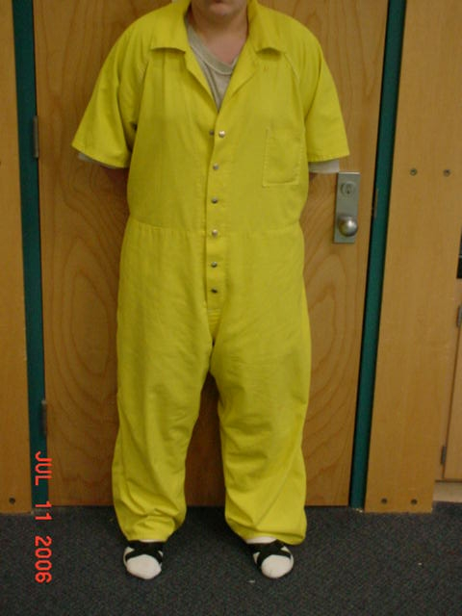

WALKING IN THE DAYROOM
When walking to the kitchen area, you are to remain on the carpet. You are not allowed to walk near the control station or cut through the tables. You must not talk to other youth while walking in the dayroom. You should never walk in front of the control station.

CLEARING TRAYS
After meals, you must request permission to clear your place at the table. A good example of this is, “Mr. Jack, may I clear please?” You must then place your spork in the designated collection area, and take your tray up to the kitchen. You should leave uneaten food on the tray, but throw away all paper products.

COOLER
The cooler in the dayroom is for the storage of milk only. You are not allowed to store frozen snacks or drinks in the cooler. Fruit placed on the cooler is available for you to eat, however, permission must be given by a counselor to get fruit. Items inside the cooler and on top of the cooler are considered off limits unless told otherwise by a counselor.
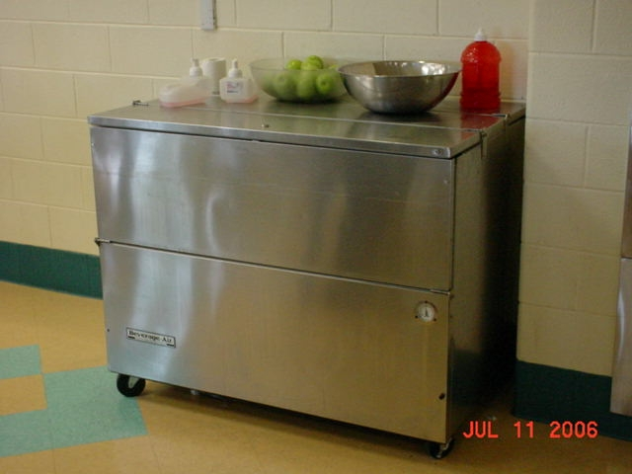

RECREATION
You are expected to participate in recreation during the scheduled times. Unless previously limited from recreation, your participation is required. Friendly competition is okay during recreation, however, rules about personal boundaries and horseplay still apply. Equipment associated with recreation must never be used in a way other than it was intended (kicking basketballs).

EMERGENCY SITUATIONS
Although they are rare, emergency situations may occur where the detention staff need to respond to keep everyone safe. When the term “CODE RED” is used, you must immediately line up, with NO TALKING, and LISTEN for staff directions. You may be instructed to go to your room for your safety until the situation is resolved.

GROUP MEETING RULES

Chairs circled up
Sit up in chair
Listen quietly
No interrupting
Only speak with the ball or with staff permission
Only pass the ball. Do NOT throw it.
Only use “I” statements
Tell the truth at all times
Stay positive
No slang
No laughing
Be respectful at all times
Only RBT group papers/folder allowed in meeting
Stay seated at all times

DAYROOM CLEANUP

Wash all windows with blue spray
Wash all surfaces with yellow spray
Wash stainless steel with pink spray
Sweep tile floor with push broom
Mop floor using floor cleaning solution
Vacuum carpeting
Clean bathroom floor, sink, and toilet with pink spray

What is a “time out”?

Time outs are for you to think about your inappropriate behavior.
A time out lasts five minutes.

We are all human beings capable of both success and failure.

As a human being, you will make mistakes and show inappropriate behavior. When you make these MISTAKES you will be told by a staff to take a time out.

A time out is not intended as a punishment.

Here are some of the things a “time out” can do for you.

- Help you become aware of your inappropriate behavior. If you know what behavior to change, it is much easier to change that behavior.

- Provide an opportunity to show the staff that you can act appropriately.

- Allow you the option of remaining in the program instead of having a major consequence for a minor mistake.

- Allow you time to identify appropriate alternatives to the behavior, which earned you a time out.

- Allow you time to decide whether appropriate behavior might be a better choice.

Most time outs are spent in program, quietly facing the wall with your arms to your side. Some time outs are spent in your room or in program re-entry time. All time outs are spent in the program except those for:

- Fighting or aggressive talk or aggressive gestures
- Destruction of property
- Sexually inappropriate behavior or talk
- Refusal to do the time out or uncooperative with the process
- Threatening others

What behavior is expected of me when doing a time out?

- Go to the wall as directed and stand about six (6) inches away from it.
- Stand straight with your hands at your side or behind your back.
- Ignore everyone except staff who talk to you.

Following your time out, and only when asked by staff, name the inappropriate behavior that earned you the time out; if requested do a thinking report.

What happens after I receive a time out?

After you have acted appropriately for Five Continuous Minutes, a staff member will ask you why you are in a time out. You are expected to state exactly why you earned the time out and accept full responsibility for the time out.

Once informed that you have answered this question you will be directed to rejoin the group.

The time out starts over again when you fail to meet the expectations of appropriate time out behavior. For example, if you stand appropriately for three minutes and then look at the TV or are reading a book, your five minute time out would start again as soon as your behavior becomes appropriate.

What happens if I don’t know why I’m in time out?
If at the end of the five minutes you do not know why you are in time out, the staff will give you an additional five minutes to think about it.

If at the end of the second five minutes you still do not know why you are in the time out, staff will tell you what it was you did to earn the time out.

You will then serve a third five minute time out and staff will come back one last time and ask you what you did to earn a time out. If you are taking a time out appropriately, the longest time you will be on time out is 15 minutes.

What are other kinds of time outs that I may earn?

There are two types of UNLOCKED room time outs:

A SHORT TIMEOUT is earned if you refuse to take a 5 minute time out or are demonstrating continuous non-compliance with the time out expectations.

If you earn a short time out, you will be required to maintain appropriate behavior in your room with the door UNLOCKED or in one of the time out areas for up to 30 minutes.

After demonstrating appropriate behavior in your UNLOCKED room, you will be required to take the original five minute time out that you refused to take. You may want to note that it does not make sense to refuse to take a time out, since you will eventually be required to take it before you come back in the program. No points or privileges can be earned while you are in a room time out.

An EXTENDED TIMEOUT is earned for any kind of aggressive, threatening or intimidating talk or gestures, or fraudulent use of facility property.

If you earn an extended time out, you will be required to maintain appropriate behavior in your room with the door UNLOCKED or in one of the time out areas for up to 60 minutes.

During the EXTENDED TIMEOUT with appropriate behavior shown, you must complete a thinking report. You must sustain appropriate behavior during the full time out period or the time will start over.

After demonstrating appropriate behavior during the time out, if required, you must take the original five minute time out that you refused to take. You may want to note that it does not make sense to refuse to take any time out, since you will eventually be required to take it before you come back in the program. No points or privileges can be earned while you are in a room time out.

What if my behavior becomes really unsafe and out of control?

A ROOM RESTRICTION is earned for behavior that is dangerous, unsafe, destructive, or harmful.

You will remain on Room Restriction until you regain self-control and can demonstrate compliance with staff directions and program expectations.

Once you regain self-control you will need to complete re-entry assignments.

What is appropriate behavior while I am in a room time out?

- Remain quiet
- Ignore everyone who talks to you, except staff
- Sit on your bed or chair, but DO NOT SLEEP (eyes open)
- Complete a thinking report if required. This will help you look at the choices you make and how things you tell yourself lead to your behaviors. Before you can return to regular programming, staff will assist you in completing a thinking report.
- Name the inappropriate behavior that earned you the time out when asked by staff

How will I learn to do time outs correctly?

After completing your orientation, staff will ask you to practice taking a time out. The purpose of this is to give you the opportunity to learn how to do it correctly, and to allow you to see how easy it is to take a time out.

Most residents here would rather be somewhere else than in this detention center. It is very easy to convince yourself that the most important thing is getting out of here as soon as possible.

Behaviors that earn a 5 Minute Timeout:

- Not meeting target skill expectations (Ignore, Cooperate/Participate, Talk, Area, Gestures)

Behaviors that earn a SHORT Timeout:

- Refusal to accept/complete 5-minute timeout
- Manipulating the start of a 5-minute timeout
- Behavior disrupting the orderly operation of the facility

Behaviors that earn an EXTENDED Timeout:
- Refusal to accept/complete SHORT timeout
- Manipulating the start of a SHORT timeout
- Fraudulent use of facility property or program materials
- Use of direct aggressive/threatening talk or gestures
- Use of discriminatory/ intimidating talk or gestures

Behaviors and Dangerous Acts that earn a ROOM RESTRICTION and/or RE-ENTRY TIME

- Refusal to accept/complete EXTENDED timeout
- Manipulating the start of an EXTENDED timeout
- Misuse of medication
- Any act that is a violation of State law.
- Incite to riot/strike or rioting/striking
- Behavior disrupting the safety/ security of the facility
- Physical aggression towards anyone
- Destruction of property
- Possession or use of illegal substances
- Possession of dangerous contraband

ONE FINAL THING WITH THE BEHAVIOR PROGRAM THAT IS THE MOST IMPORTANT!!

Changing your thinking may help you change your behavior and deal with your problems so that you will not have to ever come back here or any place like this again!

Some residents return; some do not.

The difference is that some learn to change their behavior and learn how to deal with their problems so they don’t come back.

We believe that you can succeed in this program!

